Title
AIR-AVAT: An AI-Based Predictive Maintenance and Health Monitoring System for Aircraft

Abstract
The aviation industry requires high reliability, operational efficiency, and strict safety compliance. Traditional maintenance strategies rely on fixed schedules and reactive diagnostics, which often result in unexpected component failures, flight delays, and increased operational costs. This paper proposes AIR-AVAT (Aircraft Intelligent Response – Alert, Vigilance and Analysis Technology), an Artificial Intelligence-based predictive maintenance system designed to analyze aircraft telemetry data in real time. The system employs machine learning models for anomaly detection and Remaining Useful Life (RUL) prediction, combined with a deterministic rule-based safety engine to validate predictions against aviation thresholds. An interactive dashboard enables real-time monitoring and alert visualization. The proposed framework enhances predictive accuracy, reduces downtime, and improves aviation safety.

I. Introduction
Modern aircraft systems generate high-frequency telemetry data from engines, turbines, pressure systems, and vibration sensors. Despite the availability of large-scale data, maintenance practices remain largely schedule-based or reactive. These approaches may fail to detect early degradation patterns, resulting in unexpected failures and operational inefficiencies.
Recent advances in Artificial Intelligence enable time-series analysis for predictive maintenance. AIR-AVAT integrates anomaly detection, failure prediction, and rule-based validation into a unified system aimed at improving aircraft reliability and safety.

II. Problem Statement
Unexpected aircraft component failures cause:
- Flight delays and cancellations
- Increased maintenance costs
- Reduced fleet availability
- Safety risks
Traditional monitoring systems rely on static threshold mechanisms, which do not adapt to evolving degradation trends. There is a need for an intelligent predictive system capable of continuous monitoring and proactive maintenance decision-making.

III. Literature Review
Predictive maintenance in aerospace has been widely studied using benchmark datasets such as NASA’s Prognostics Data Repository and the C-MAPSS turbofan engine dataset.
Existing approaches include:
- Statistical anomaly detection models
- Machine learning methods such as Isolation Forest
- Deep learning models including Long Short-Term Memory (LSTM) networks for RUL estimation
However, most AI-based systems depend solely on model predictions without incorporating deterministic safety validation. AIR-AVAT improves reliability by combining machine learning predictions with rule-based guardrail mechanisms.

IV. Proposed System
AIR-AVAT consists of five core layers:
- Data Acquisition Layer
- Preprocessing and Feature Engineering Layer
- Machine Learning Prediction Layer
- Deterministic Safety Engine
- Visualization and Alert Dashboard
The system architecture ensures modularity, scalability, and reliability.
V. System Architecture Diagram Section
- Overall System Architecture
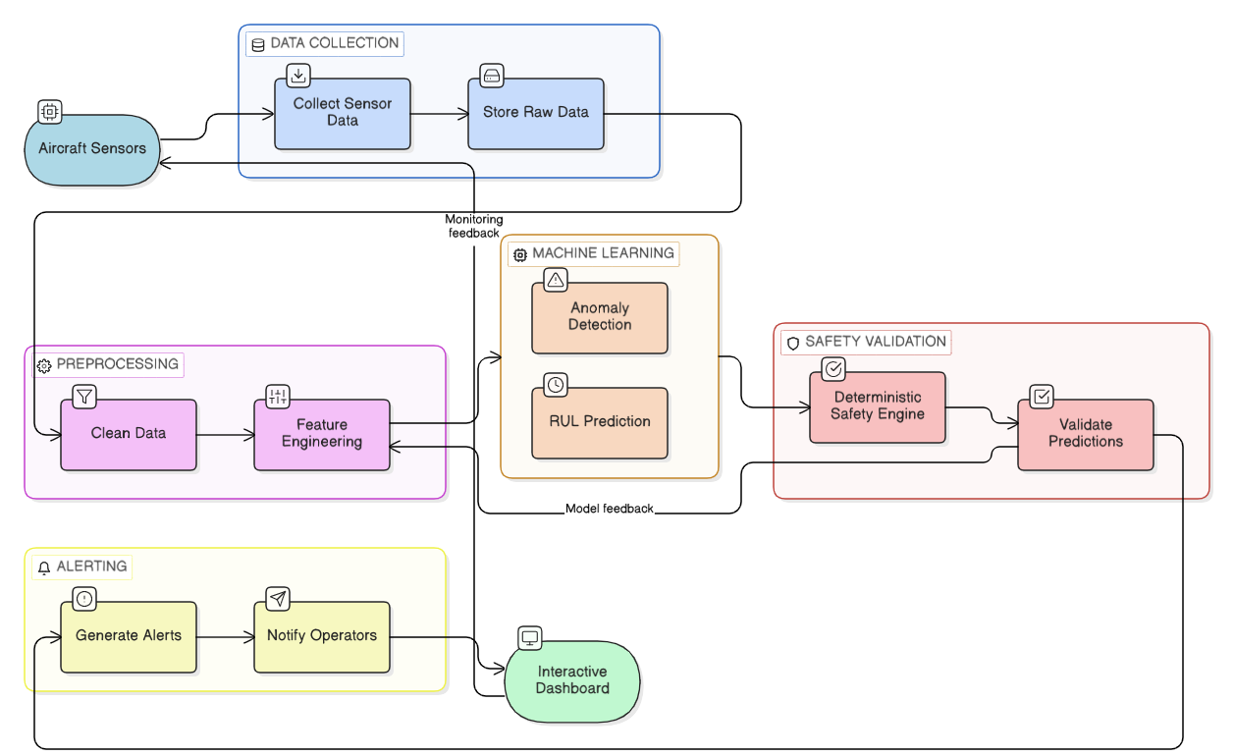

- Data Flow Diagram
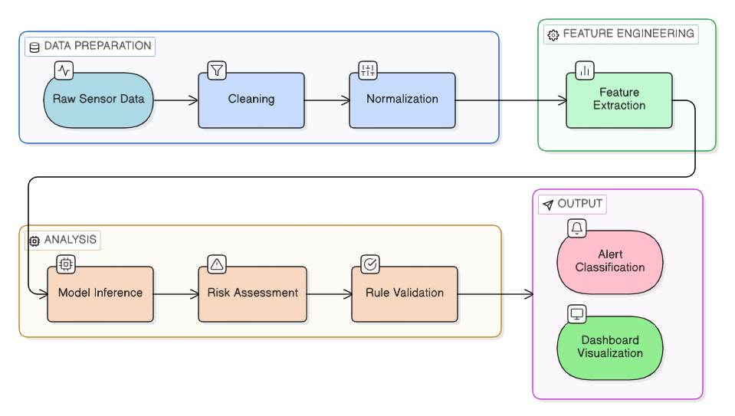

- Health Classification Workflow

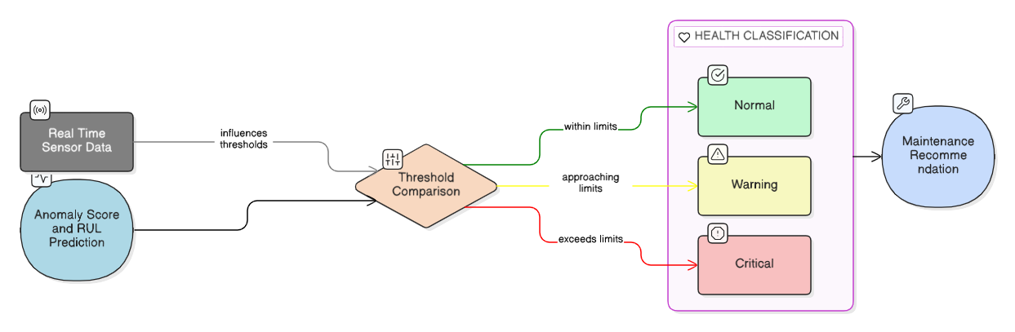
VI. Implementation
The system is implemented using:
- Python (FastAPI) for backend API
- Scikit-learn and TensorFlow for ML model development
- Dash and Plotly for interactive dashboard
- PostgreSQL for logging and alert storage

Implementation Steps:
- Dataset preprocessing and normalization
- Model training for anomaly detection
- RUL regression model training
- Development of deterministic rule engine
- API integration and dashboard deployment

VII. Mathematical Modeling
Anomaly Detection (Isolation Forest Concept)
Anomaly score:
$$Score\left(x\right)=2^{-\frac{E\left(h\left(x\right)\right)}{c\left(n\right)}}$$
Where:
- $E\left(h\left(x\right)\right)$ = Expected path length
- $c\left(n\right)$ = Average path length for sample size n

Remaining Useful Life Prediction
RUL is modeled as:
$$RUL=f\left(X_{t}\right)$$
Where:
- $X_{t}$ = Time-series sensor input
- $f$ = Learned regression function (LSTM / ML model)

VIII. Expected Results
The proposed system is expected to:
- Detect early degradation patterns
- Accurately estimate RUL
- Reduce unexpected downtime
- Improve fleet maintenance planning
- Enhance operational safety
Model performance will be evaluated using:
- Mean Absolute Error (MAE) for RUL prediction
- Precision and Recall for anomaly detection
- Confusion Matrix for classification

IX. Future Scope
- Real-time deployment on aircraft telemetry
- Edge AI integration
- Digital twin simulation
- Explainable AI for regulatory compliance
- Integration with airline ERP systems

X. Conclusion
AIR-AVAT presents a robust AI-driven predictive maintenance framework tailored for aviation systems. By integrating anomaly detection, RUL estimation, and deterministic safety validation, the system ensures predictive intelligence while maintaining regulatory compliance. The proposed model demonstrates the transformative potential of Artificial Intelligence in high-risk aerospace environments.

XI. References
- NASA Prognostics Data Repository
- Saxena, A., et al., "Damage Propagation Modeling for Aircraft Engine Run-to-Failure Simulation."
- C-MAPSS Turbofan Engine Degradation Simulation Dataset
- Scikit-learn Documentation
- TensorFlow Documentation
- Research Papers on Predictive Maintenance in Aerospace Systems

